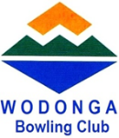

**WODONGA**

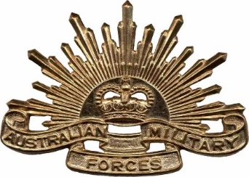

*Mike Bodman*

*Anzac Day Open Triples*

*Tournament*

*Sponsored By*

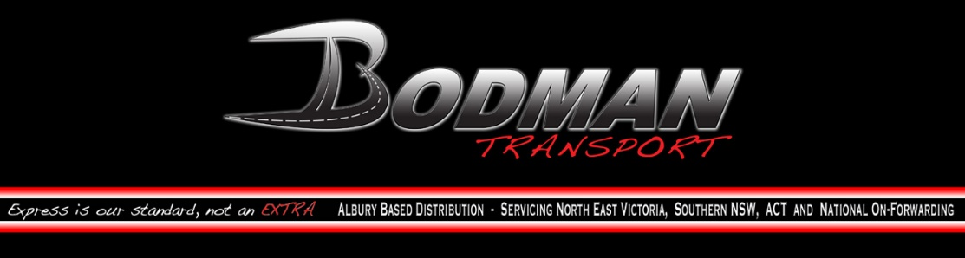

[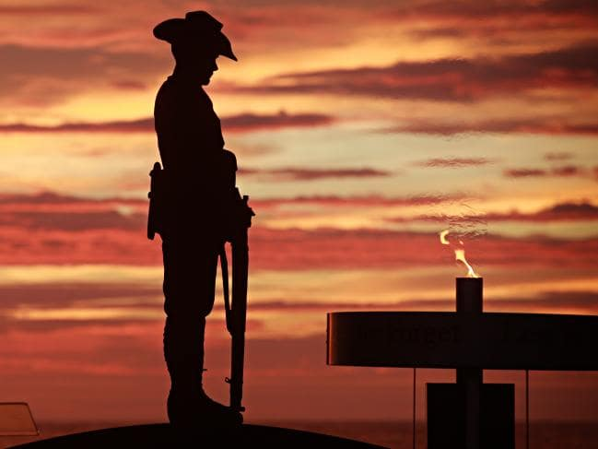](https://www.google.com.au/url?sa=i&rct=j&q=&esrc=s&source=images&cd=&cad=rja&uact=8&ved=2ahUKEwi-6cvkjPfgAhVKOisKHR6SBJoQjRx6BAgBEAU&url=https://www.news.com.au/national/anzac-day-2017-dawn-services-and-marches-in-australia-and-overseas/news-story/4b09dbf1315e0b9fd7f08e1ee6ef68c7&psig=AOvVaw0m27PNLgIZ7V1ouiVIu7Tq&ust=1552290973090719)

Saturday April 25 2020 ~ 1.00pm

3 Games of 2 Bowl Triples ~ 12 Ends

Team or Single Entry @ $20.00 per player

**1st $750 ~ 2nd $360 ~ 3rd $240**

**4th $150 ~ 5th $120**

Best Game each round $60

(Excludes Major Prize Winners)

Includes

sAUSAGE sIZZLE @11.45AM

Afternoon Tea

**ENTRIES CLOSE: Wednesday April 22 2020**

Email: [lesley.wbc@outlook.com](mailto:lesley.wbc@outlook.com)

Ashley Bates: 0427 872 341

Wodonga Bowls Club : 0260 241 554